INTRODUCTION TO MODELSIM AND GATE LEVEL

MODELING

LAB # 01



Spring 2025

CSE-308L

Digital System Design Lab

Submitted by: Naveed Ahmad

Registration No.: 22PWCSE2165

Class Section: B

Student Signature: ______________

Submitted to:

Engr. Shah Zada Fahim Jan

05 March 2025

Department of Computer Systems Engineering

University of Engineering and Technology, Peshawar

Introduction To Modalism and Gate Level Modeling

OBJECTIVES

* Introduction to MODELSIM
* Introduction to gate level modeling

Lab Tasks:

Task 1: Implement a buffer at the gate level

Code

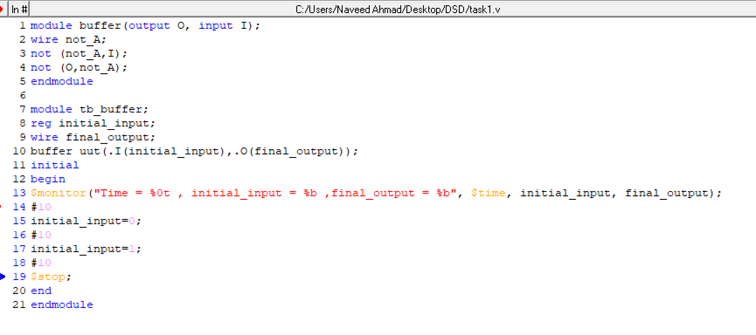

Output:

Task 2: Implement an inverter at the gate level.

Code

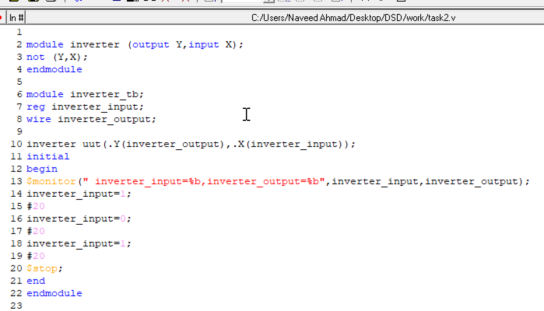

Output:



Task 3: Implement an OR gate using a NAND gates.

Code

Output*:*

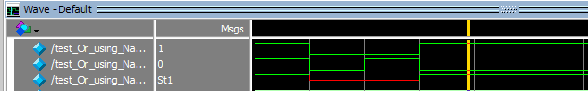

Task 4: Implement the following equation where z is output and x1, x2, x3, x4, and x5 are inputs of the circuit.

z = (y1 + y2)’

y1 = x1 . x2

Code:

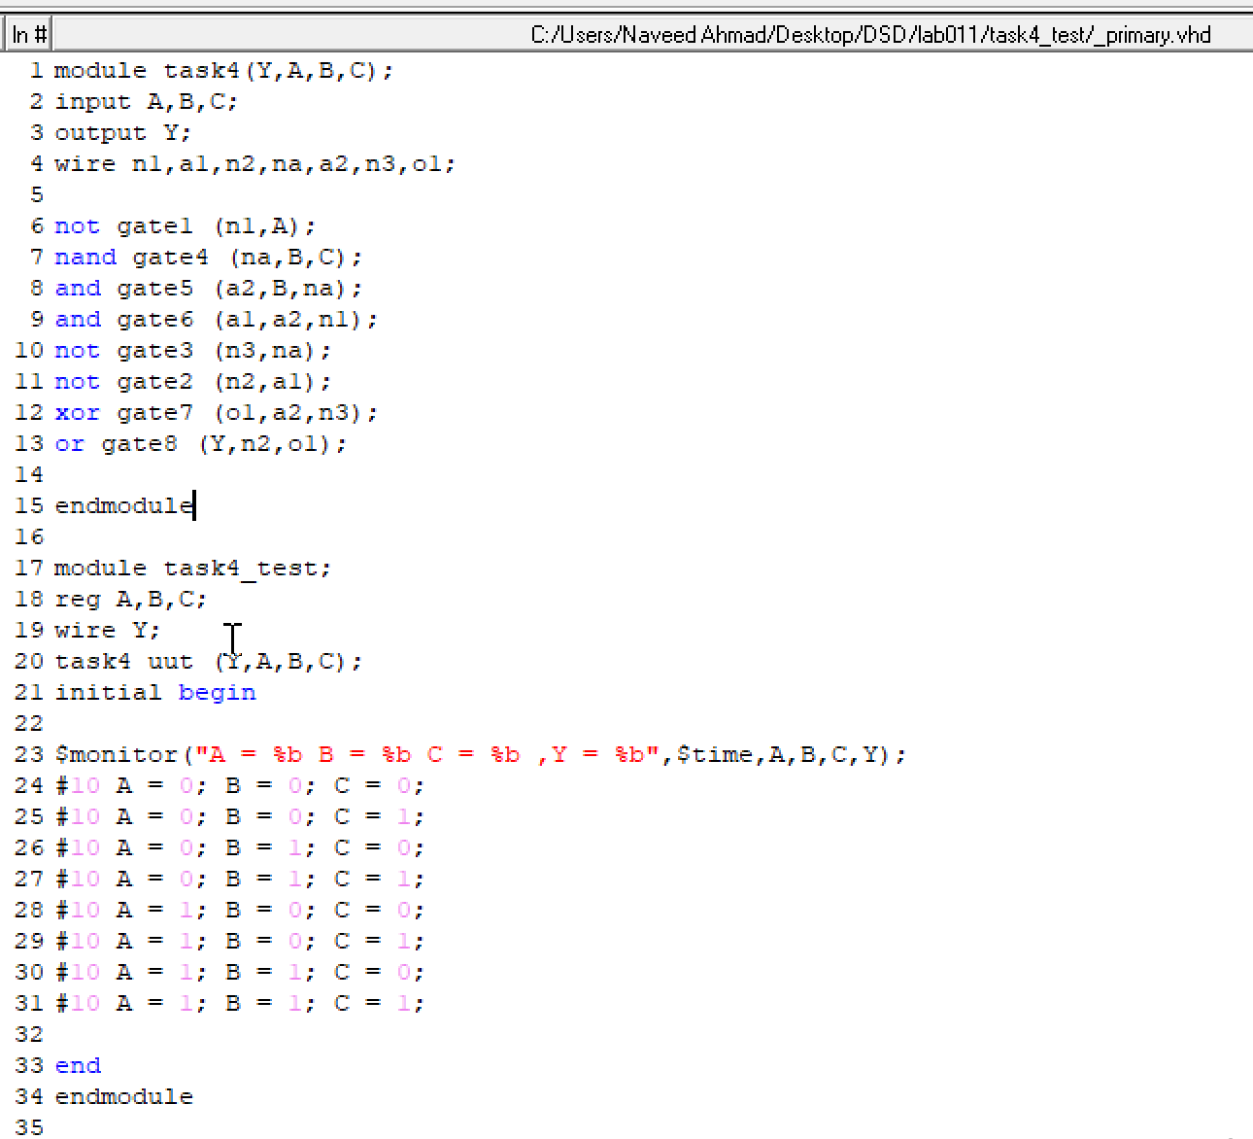

Truth table:

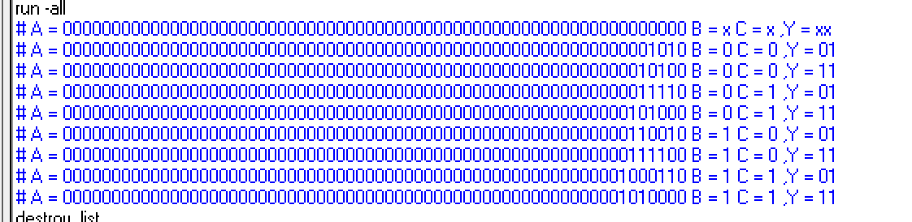

Data flow :

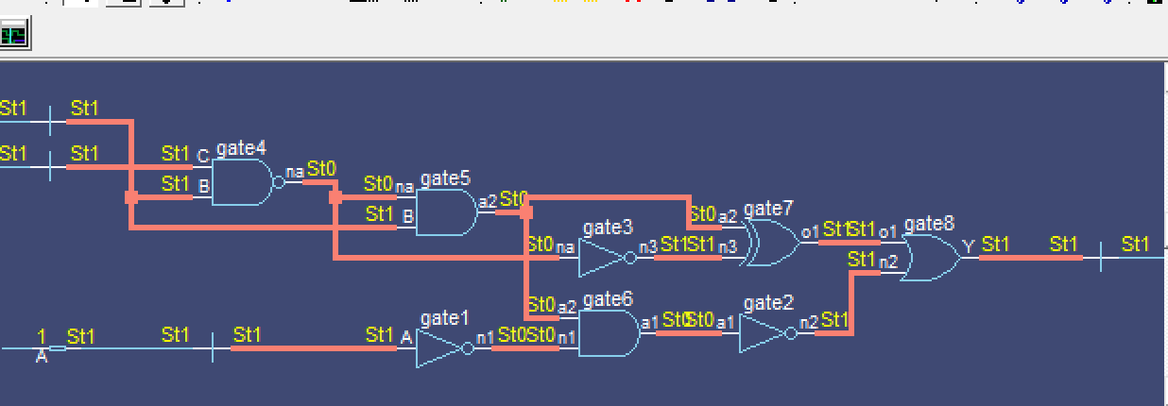

Output:

